**Model 1**: VGG16 - best epoch 33 - 4:30h  
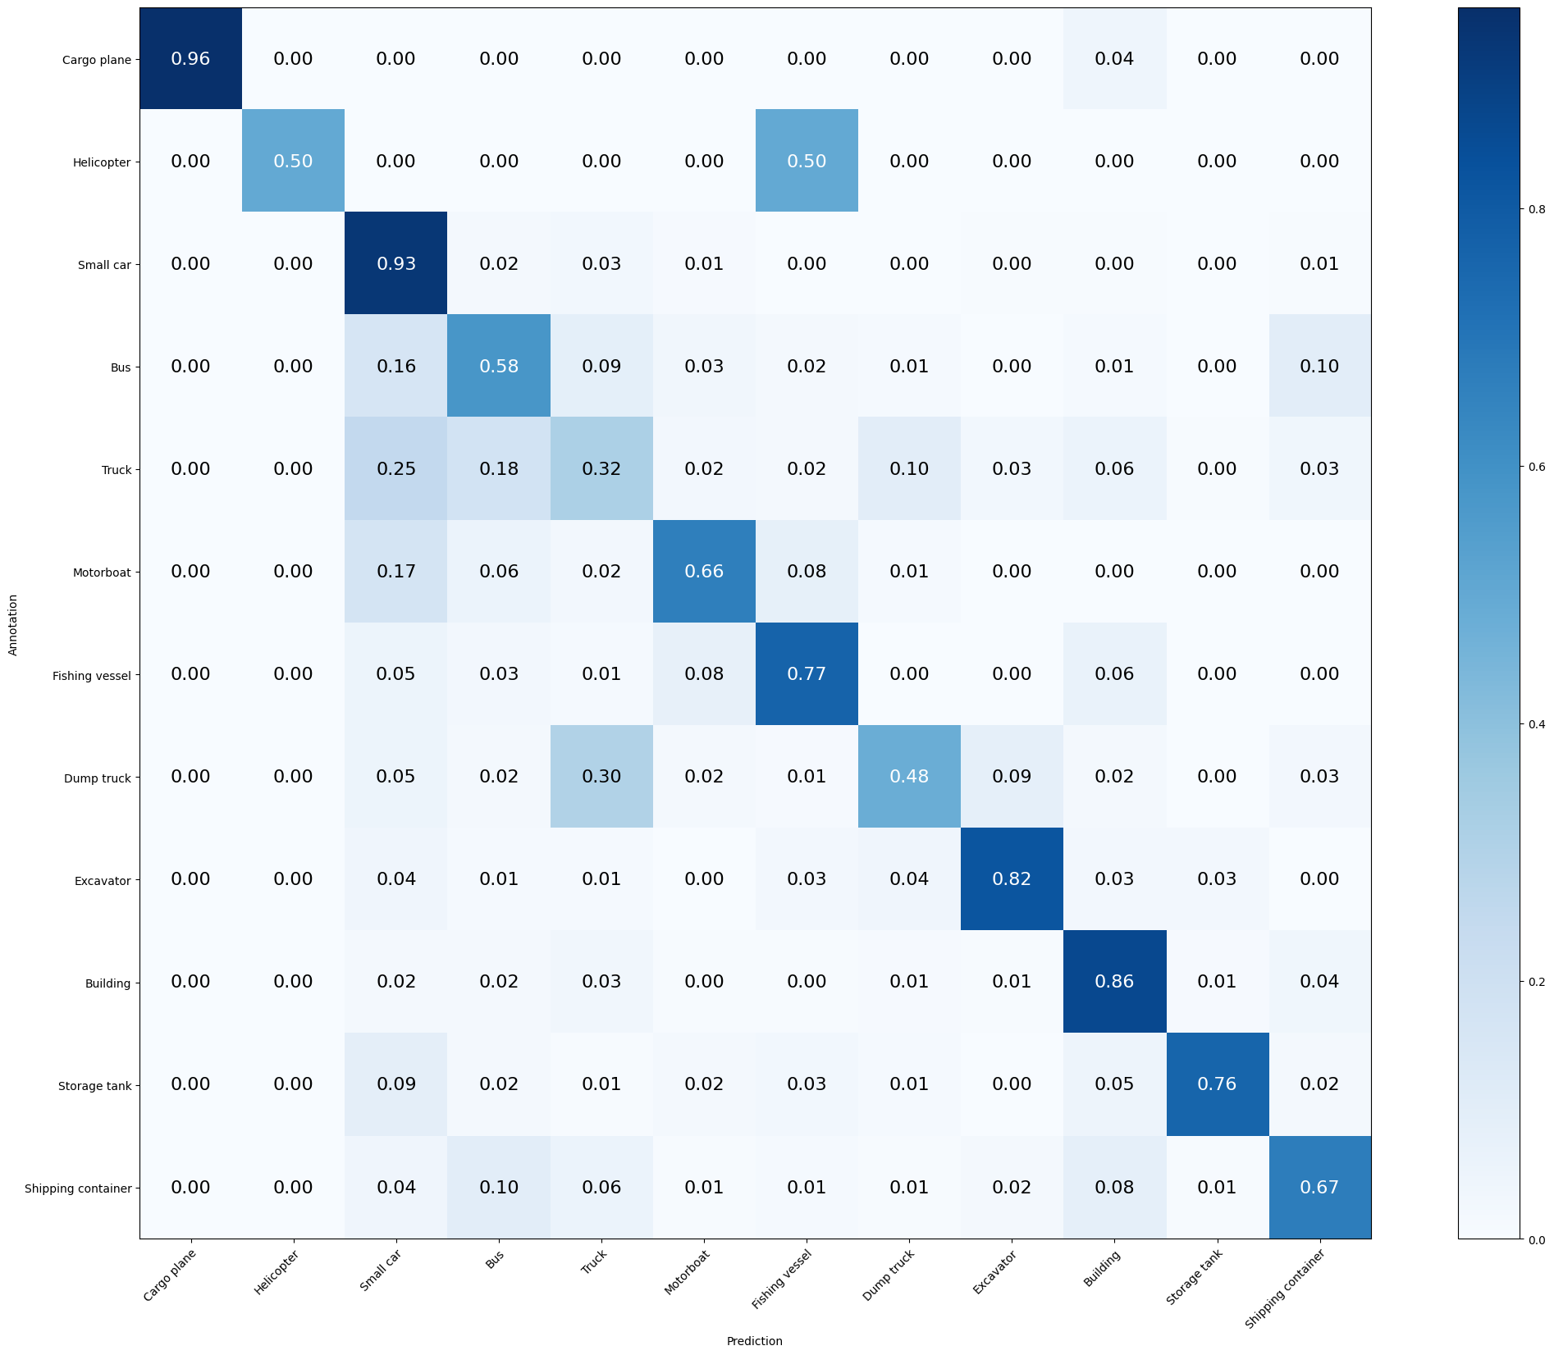

Mean Accuracy: 72.544%

Mean Recall: 69.122%

Mean Precision: 69.735%

> Cargo plane: Recall: 95.588% Precision: 100.000% Specificity: 100.000% Dice: 97.744%

> Helicopter: Recall: 50.000% Precision: 50.000% Specificity: 99.953% Dice: 50.000%

> Small car: Recall: 92.619% Precision: 71.245% Specificity: 90.861% Dice: 80.538%

> Bus: Recall: 57.534% Precision: 57.534% Specificity: 95.154% Dice: 57.534%

> Truck: Recall: 31.698% Precision: 46.927% Specificity: 94.928% Dice: 37.838%

> Motorboat: Recall: 66.292% Precision: 65.556% Specificity: 98.487% Dice: 65.922%

> Fishing vessel: Recall: 76.623% Precision: 68.605% Specificity: 98.690% Dice: 72.393%

> Dump truck: Recall: 47.863% Precision: 58.333% Specificity: 98.021% Dice: 52.582%

> Excavator: Recall: 82.051% Precision: 71.910% Specificity: 98.786% Dice: 76.647%

> Building: Recall: 86.492% Precision: 89.189% Specificity: 96.833% Dice: 87.820%

> Storage tank: Recall: 75.817% Precision: 93.548% Specificity: 99.597% Dice: 83.755%

> Shipping container: Recall: 66.883% Precision: 63.975% Specificity: 97.077% Dice: 65.397%

**Model 2**: VGG19 - best epoch 59 - 6h aprox

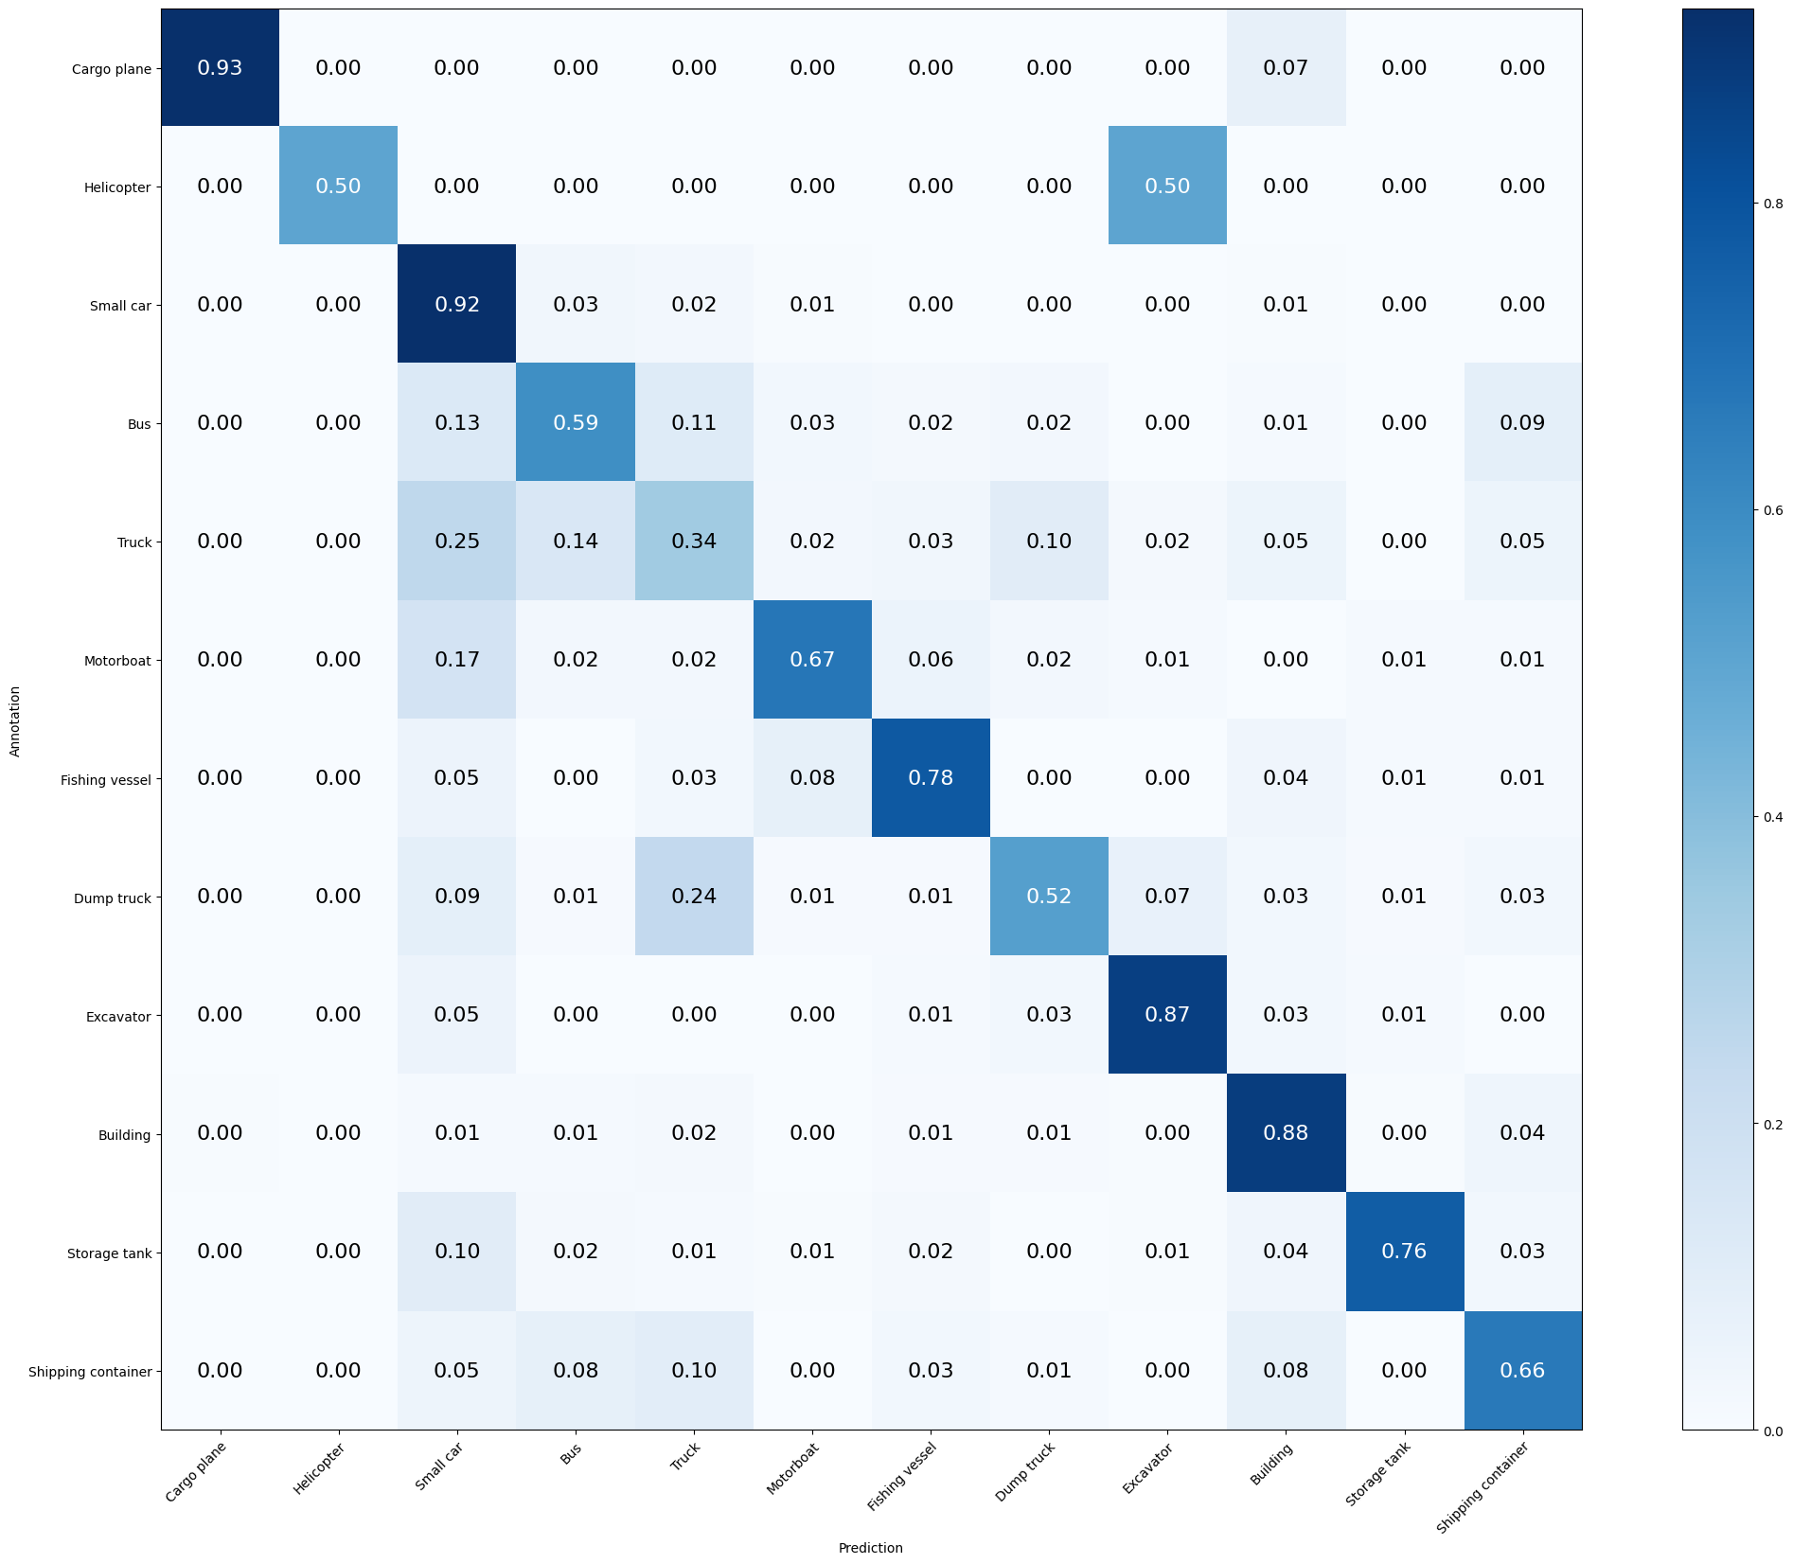

Mean Accuracy: 73.667%

Mean Recall: 70.263%

Mean Precision: 70.981%

> Cargo plane: Recall: 92.647% Precision: 96.923% Specificity: 99.903% Dice: 94.737%

> Helicopter: Recall: 50.000% Precision: 50.000% Specificity: 99.953% Dice: 50.000%

> Small car: Recall: 92.381% Precision: 71.062% Specificity: 90.803% Dice: 80.331%

> Bus: Recall: 58.904% Precision: 63.547% Specificity: 96.144% Dice: 61.137%

> Truck: Recall: 33.962% Precision: 49.451% Specificity: 95.088% Dice: 40.268%

> Motorboat: Recall: 67.416% Precision: 71.429% Specificity: 98.829% Dice: 69.364%

> Fishing vessel: Recall: 77.922% Precision: 65.934% Specificity: 98.496% Dice: 71.429%

> Dump truck: Recall: 52.137% Precision: 58.095% Specificity: 97.823% Dice: 54.955%

> Excavator: Recall: 87.179% Precision: 79.070% Specificity: 99.126% Dice: 82.927%

> Building: Recall: 87.903% Precision: 89.712% Specificity: 96.955% Dice: 88.798%

> Storage tank: Recall: 76.471% Precision: 94.355% Specificity: 99.647% Dice: 84.477%

> Shipping container: Recall: 66.234% Precision: 62.195% Specificity: 96.875% Dice: 64.151%

**Model 3**: ResNet50 - best epoch 58- 6h aprox

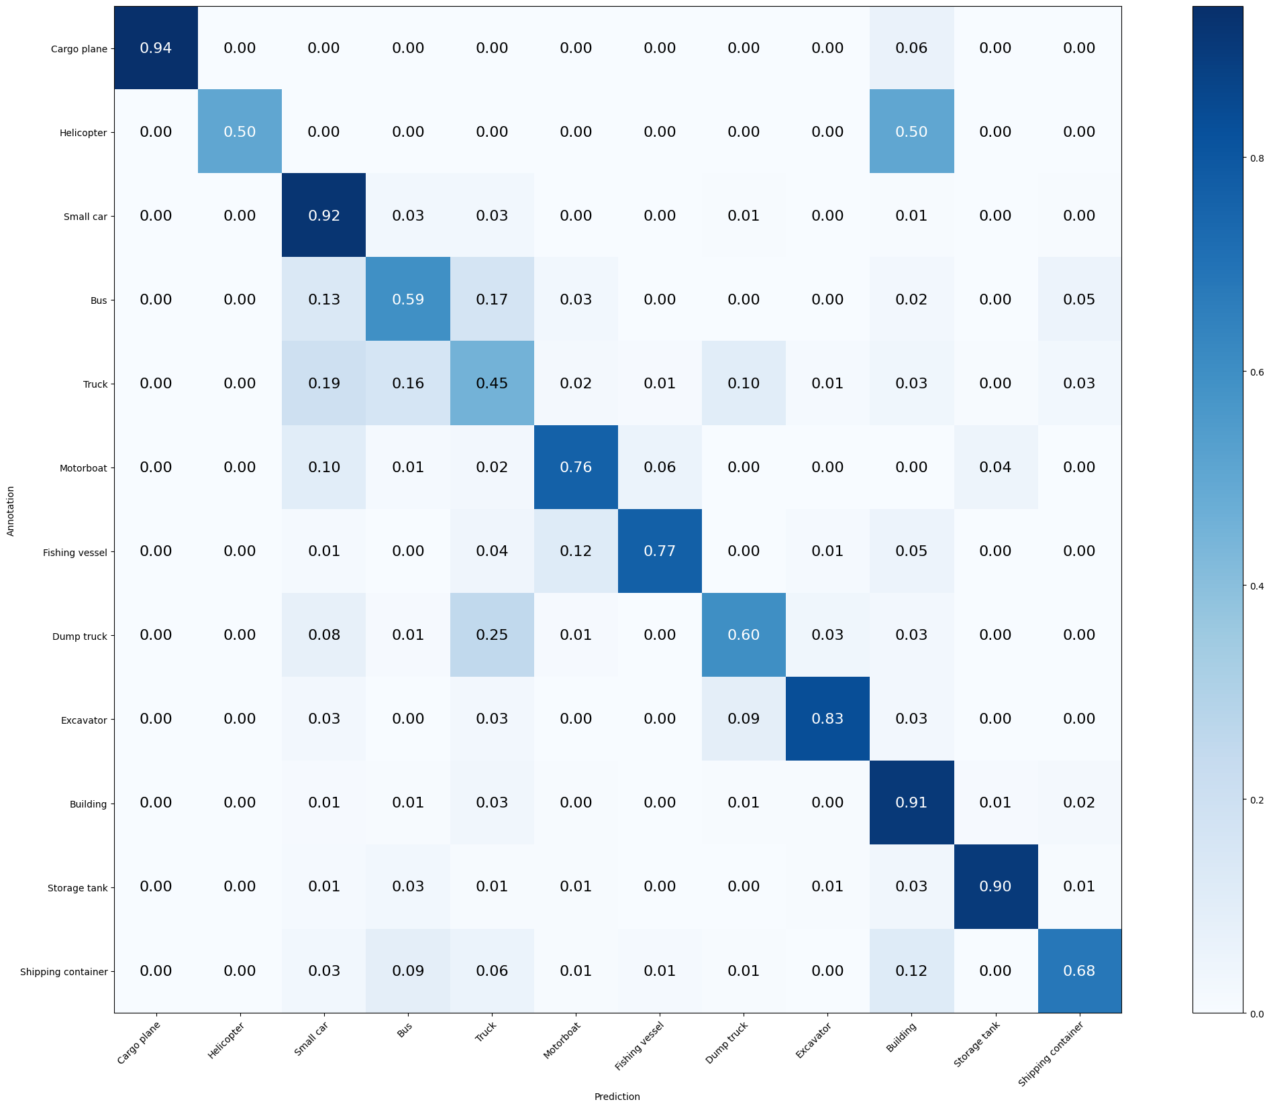

Mean Accuracy: 77.456%

Mean Recall: 73.818%

Mean Precision: 75.779%

> Cargo plane: Recall: 94.118% Precision: 100.000% Specificity: 100.000% Dice: 96.970%

> Helicopter: Recall: 50.000% Precision: 50.000% Specificity: 99.953% Dice: 50.000%

> Small car: Recall: 92.143% Precision: 77.555% Specificity: 93.481% Dice: 84.222%

> Bus: Recall: 59.361% Precision: 63.107% Specificity: 96.040% Dice: 61.176%

> Truck: Recall: 44.906% Precision: 51.739% Specificity: 94.074% Dice: 48.081%

> Motorboat: Recall: 76.404% Precision: 73.118% Specificity: 98.780% Dice: 74.725%

> Fishing vessel: Recall: 76.623% Precision: 85.507% Specificity: 99.515% Dice: 80.822%

> Dump truck: Recall: 59.829% Precision: 63.063% Specificity: 97.971% Dice: 61.404%

> Excavator: Recall: 83.333% Precision: 85.526% Specificity: 99.466% Dice: 84.416%

> Building: Recall: 90.726% Precision: 89.286% Specificity: 96.711% Dice: 90.000%

> Storage tank: Recall: 90.196% Precision: 93.243% Specificity: 99.496% Dice: 91.694%

> Shipping container: Recall: 68.182% Precision: 77.206% Specificity: 98.438% Dice: 72.414%

**Model 4**: Xception + RandomFlip, RandomRotation + RandomZoom

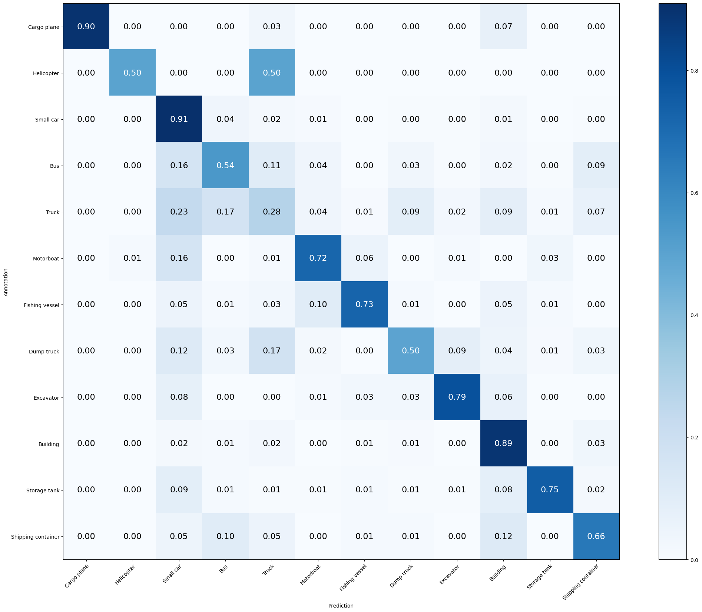

Mean Accuracy: 71.749%

Mean Recall: 68.008%

Mean Precision: 69.758%

> Cargo plane: Recall: 89.706% Precision: 100.000% Specificity: 100.000% Dice: 94.574%

> Helicopter: Recall: 50.000% Precision: 50.000% Specificity: 99.953% Dice: 50.000%

> Small car: Recall: 90.952% Precision: 69.835% Specificity: 90.396% Dice: 79.007%

> Bus: Recall: 54.338% Precision: 57.767% Specificity: 95.466% Dice: 56.000%

> Truck: Recall: 27.547% Precision: 48.667% Specificity: 95.889% Dice: 35.181%

> Motorboat: Recall: 71.910% Precision: 65.306% Specificity: 98.341% Dice: 68.449%

> Fishing vessel: Recall: 72.727% Precision: 77.778% Specificity: 99.224% Dice: 75.168%

> Dump truck: Recall: 49.573% Precision: 57.426% Specificity: 97.872% Dice: 53.211%

> Excavator: Recall: 79.487% Precision: 73.810% Specificity: 98.932% Dice: 76.543%

> Building: Recall: 89.113% Precision: 84.030% Specificity: 94.884% Dice: 86.497%

> Storage tank: Recall: 75.163% Precision: 91.270% Specificity: 99.446% Dice: 82.437%

> Shipping container: Recall: 65.584% Precision: 61.212% Specificity: 96.774% Dice: 63.323%

**Model 5**: InceptionResNetV2 + ImageDataGenerator

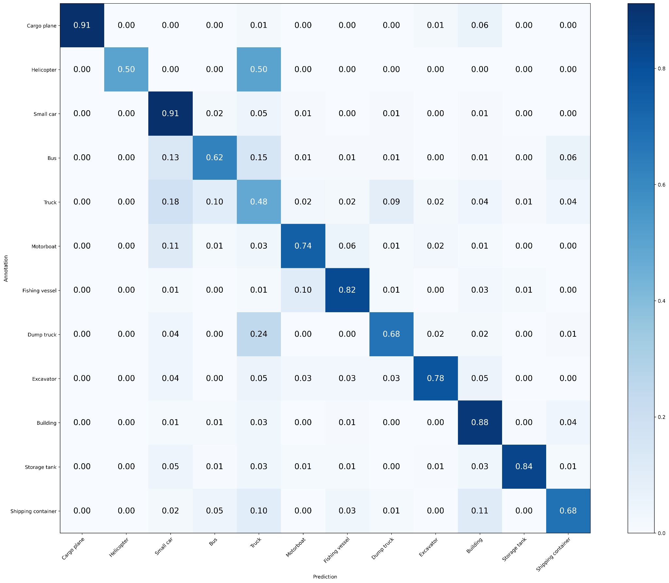

Mean Accuracy: 77.035%

Mean Recall: 73.647%

Mean Precision: 79.338%

> Cargo plane: Recall: 91.176% Precision: 100.000% Specificity: 100.000% Dice: 95.385%

> Helicopter: Recall: 50.000% Precision: 100.000% Specificity: 100.000% Dice: 66.667%

> Small car: Recall: 90.714% Precision: 76.970% Specificity: 93.364% Dice: 83.279%

> Bus: Recall: 62.100% Precision: 73.514% Specificity: 97.447% Dice: 67.327%

> Truck: Recall: 47.925% Precision: 50.198% Specificity: 93.273% Dice: 49.035%

> Motorboat: Recall: 74.157% Precision: 72.527% Specificity: 98.780% Dice: 73.333%

> Fishing vessel: Recall: 81.818% Precision: 72.414% Specificity: 98.836% Dice: 76.829%

> Dump truck: Recall: 67.521% Precision: 68.696% Specificity: 98.219% Dice: 68.103%

> Excavator: Recall: 78.205% Precision: 84.722% Specificity: 99.466% Dice: 81.333%

> Building: Recall: 88.306% Precision: 89.571% Specificity: 96.894% Dice: 88.934%

> Storage tank: Recall: 83.660% Precision: 94.815% Specificity: 99.647% Dice: 88.889%

> Shipping container: Recall: 68.182% Precision: 68.627% Specificity: 97.581% Dice: 68.404%

**Model 6**: ResNet50 (*15 layers unfreeze*) - best epoch xx - xh aprox

**Model 7**: ResNet50 (*35 layers unfreeze*) - best epoch xx - xh aprox

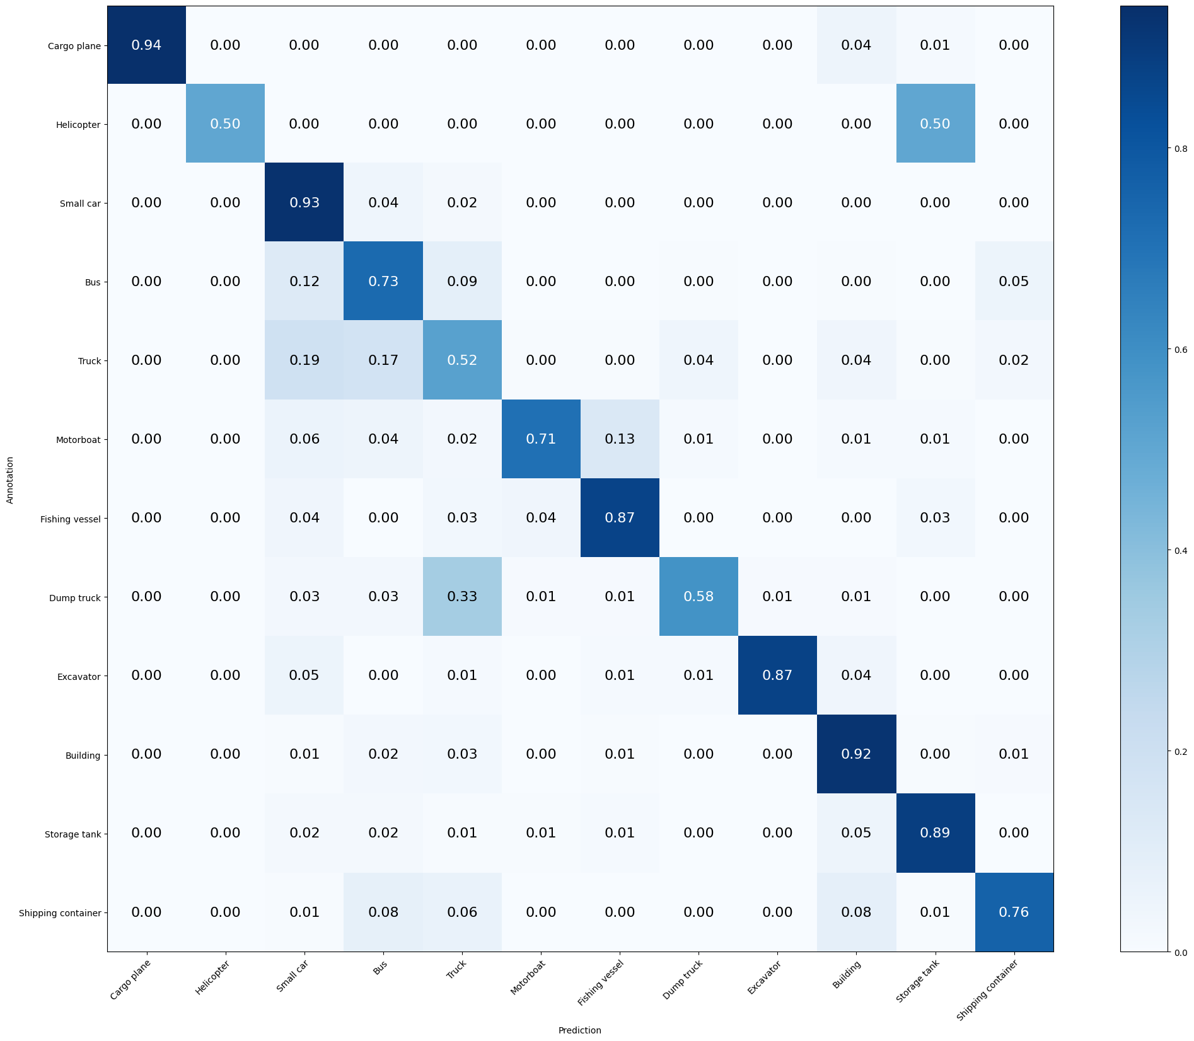

Mean Accuracy: 81.010%

Mean Recall: 76.919%

Mean Precision: 84.852%

> Cargo plane: Recall: 94.118% Precision: 100.000% Specificity: 100.000% Dice: 96.970%

> Helicopter: Recall: 50.000% Precision: 100.000% Specificity: 100.000% Dice: 66.667%

> Small car: Recall: 93.095% Precision: 79.796% Specificity: 94.237% Dice: 85.934%

> Bus: Recall: 73.059% Precision: 62.500% Specificity: 94.997% Dice: 67.368%

> Truck: Recall: 52.453% Precision: 59.149% Specificity: 94.875% Dice: 55.600%

> Motorboat: Recall: 70.787% Precision: 90.000% Specificity: 99.658% Dice: 79.245%

> Fishing vessel: Recall: 87.013% Precision: 77.011% Specificity: 99.030% Dice: 81.707%

> Dump truck: Recall: 58.120% Precision: 81.928% Specificity: 99.258% Dice: 68.000%

> Excavator: Recall: 87.179% Precision: 98.551% Specificity: 99.951% Dice: 92.517%

> Building: Recall: 92.339% Precision: 91.968% Specificity: 97.564% Dice: 92.153%

> Storage tank: Recall: 88.889% Precision: 93.151% Specificity: 99.496% Dice: 90.970%

> Shipping container: Recall: 75.974% Precision: 84.173% Specificity: 98.891% Dice: 79.863%

**Model 8**: ResNet50 (*55 layers unfreeze*) - best epoch xx - xh aprox